|  |
| --- |
| Circle Language Spec: Inheritance |

## System Commands Extension By Overriding (Questionnable)

This is a technique that will not work. The idea is that you accomplish command extension by employing the overriding concept. The idea is that you override the base command, executing your own procedure and call the base command from your own procedure.

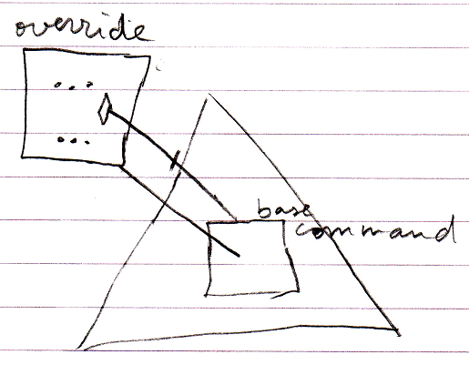

The problem with this technique however, is that the call to the base command immediately detours to the derived command again, causing an infinite loop.

However, extending system commands by *shadowing* does work.